802.11ac 1200Mbps Compact Wireless USB Adapter
WL-AC-1200M-B
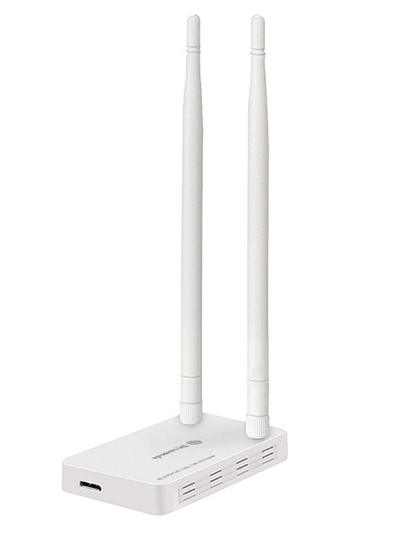

Descrption:

Looking for a high-performance, high-gain next generation WiFi adapter so you can get the best possible experience from your next generation apps, HD movie streaming and even enjoy fluid game play?

The WL-AC-1200M-B is a feature-rich USB3 compact WiFi adapter that is able to communicated via WiFi at up to a blistering 1200Mbps. Fully compliant with the latest 802.11ac standards also means it is capable of automatically switching from the standard 2.4Ghz frequency to the less congested 5Ghz standard, ideal for busy office environments or when many WiFi devices are operating in close proximity.

Featuring a pair of high-gain, extended reach antennas, advanced WiFi encryption and total Plug n' Play capabilities with WindowsTM, MacTM OS X and LinuxTM means the new WL-AC-1200M-B offers maximum flexibility with current and future broadband and access point hardware.

Features:
- Dual-band 802.11AC WiFi connectivity
- Dual high-gain omni-directional antennas
- Up to 1200Mbps WiFi communications
- 2.4Ghz and 5Ghz congestion free WiFi
- Enhanced WiFi Encryption to keep signals safe
- Feature-rich, compact design for all scenarios
- Ideal for current, future and existing WiFi Routers etc
- Plug n' Play for WindowsTM, MacTM OS X and LinuxTM

SPECIFICATIONS:
Standards | IEEE 802.11ac, 11a, 11n, 11g, 11b
Wireless Signal Rates  With Automatic Fallback | 11ac: Up to 433Mbps(Dynamic)
 | 11n: Up to 150Mbps (Dynamic)
 | 11g: Up to 54Mbps (Dynamic)
 | 11b: Up to 11Mbps (Dynamic)
Chipset | RTL8812AU
Frequency Range | 2.4-2.4835GHz/4.92-5.945GHz
Wireless Transmit Power | 18dBm (EIRP)
Modulation Type | DBPSK, DQPSK, CCK, OFDM
Receiver Sensitivity | 433M: -53dBm@10%PER
 | 150M: -68dBm@10% PER
 | 54M: -72dBm@10% PER
 | 11M: -85dBm@8% PER
Work Mode | Ad-Hoc Infrastructure ,soft AP
Wireless Security | WPS,64/128bit
 | WEP, WPA/WPA2, WPA-PSK/WPA2-PSK(TKIP/AES)
Support Operating System | Windows Vista/Win7/Win8/Win10/Linux/Mac OS
Interface | USB3.0 Hi-Speed connector
Antenna Type | Yes
Dimensions | 88mm×53mm×13.5mm
Package Content | USB adapter
 | Setup CD
Operating Temperature | 0°C~40°C (32°F~104°F)
Storage Temperature | -40°C~70°C (-40°F~158°F)
Relative Humidity | 10% ~ 90%, non condensation
Storage Humidity | 5%~95% non-condensing

